**TITLE OF LAB: (INTRODUCTION TO THE POWER OF SIGNAL, FOURIER SERIES, SQUARE AND TRIANGULAR WAVES)**

**LAB # 09**



**Spring 2022**

**CSE301L Signals & Systems Lab**

Submitted by: **Safi Ullah Khan**

Registration No.: **20PWCSE1943**

Class Section: **B**

“On my honor, as student of University of Engineering and Technology, I have neither given nor received unauthorized assistance on this academic work.”

Student Signature: ______________

Submitted to:

**Engr. Durr-e-Nayab**

Day, Date (e.g Monday, June 20th, 2022)

**Department of Computer Systems Engineering**

**University of Engineering and Technology, Peshawar**

**OBJECTIVES OF THE LAB**

**‐‐‐‐‐‐‐‐‐‐‐‐‐‐‐‐‐‐‐‐‐‐‐‐‐‐‐‐‐‐‐‐‐‐‐‐‐‐‐‐‐‐‐‐‐‐‐‐‐‐‐‐‐‐‐‐‐‐‐‐‐‐‐‐‐‐‐‐‐‐‐‐‐‐‐‐**

In this lab, we will cover the following topics:

* Power of Continuous & Discrete time Signals
* Application of Fourier Series
* Synthesis of Square Wave
* Synthesis of Triangular Wave

**‐‐‐‐‐‐‐‐‐‐‐‐‐‐‐‐‐‐‐‐‐‐‐‐‐‐‐‐‐‐‐‐‐‐‐‐‐‐‐‐‐‐‐‐‐‐‐‐‐‐‐‐‐‐‐‐‐‐‐‐‐‐‐‐‐‐‐‐‐‐‐‐‐‐‐‐--**

**-------------------------TASK 01--------------------------**

* Calculate the power of discrete‐time cosine signal with period 20, defined over interval 0:19 using the following formula:

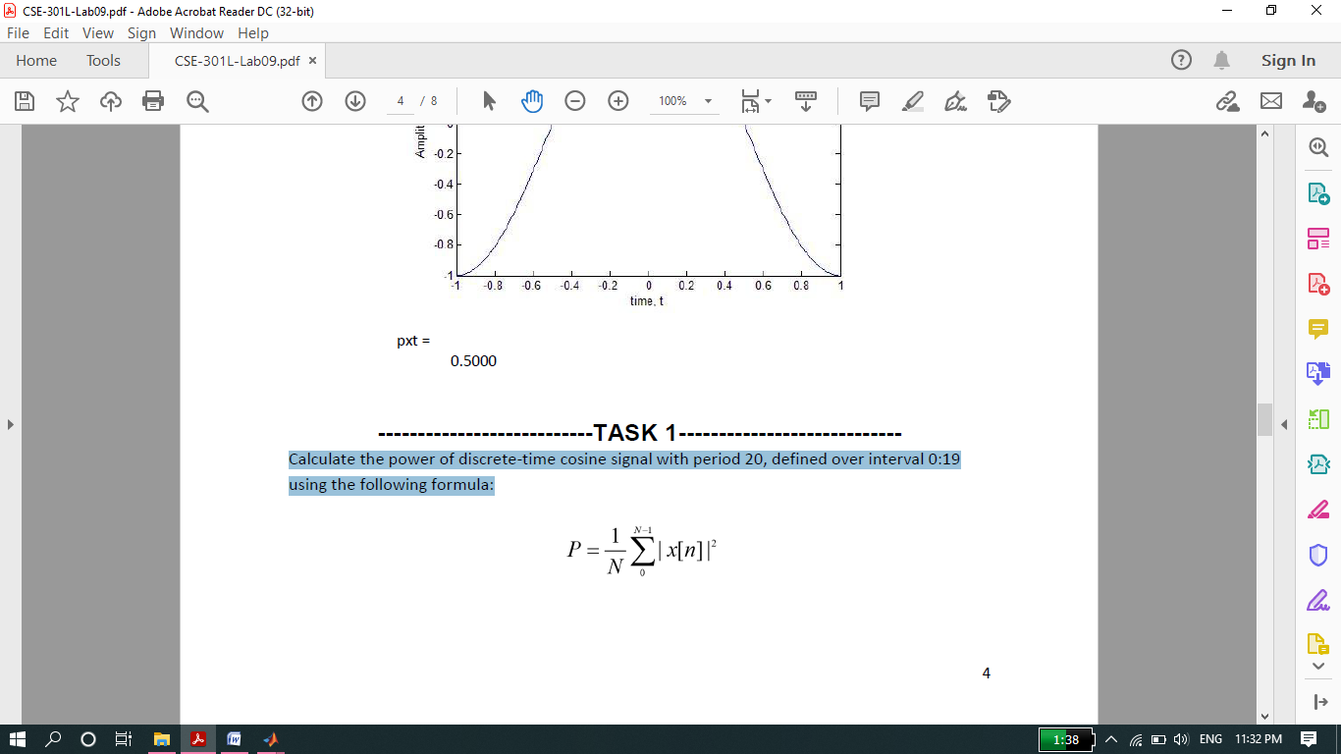

**Screenshot of Input:**

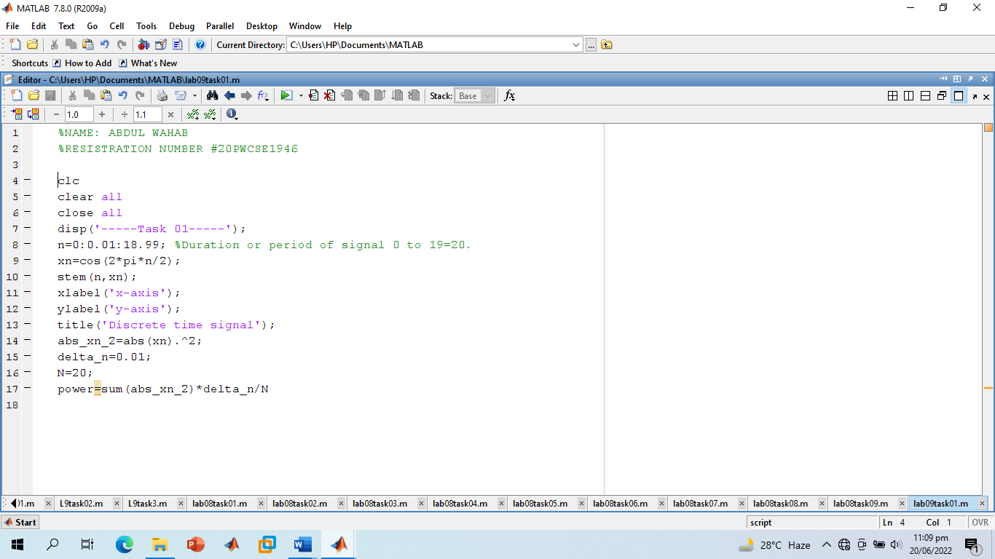

**Screenshot of Output:**

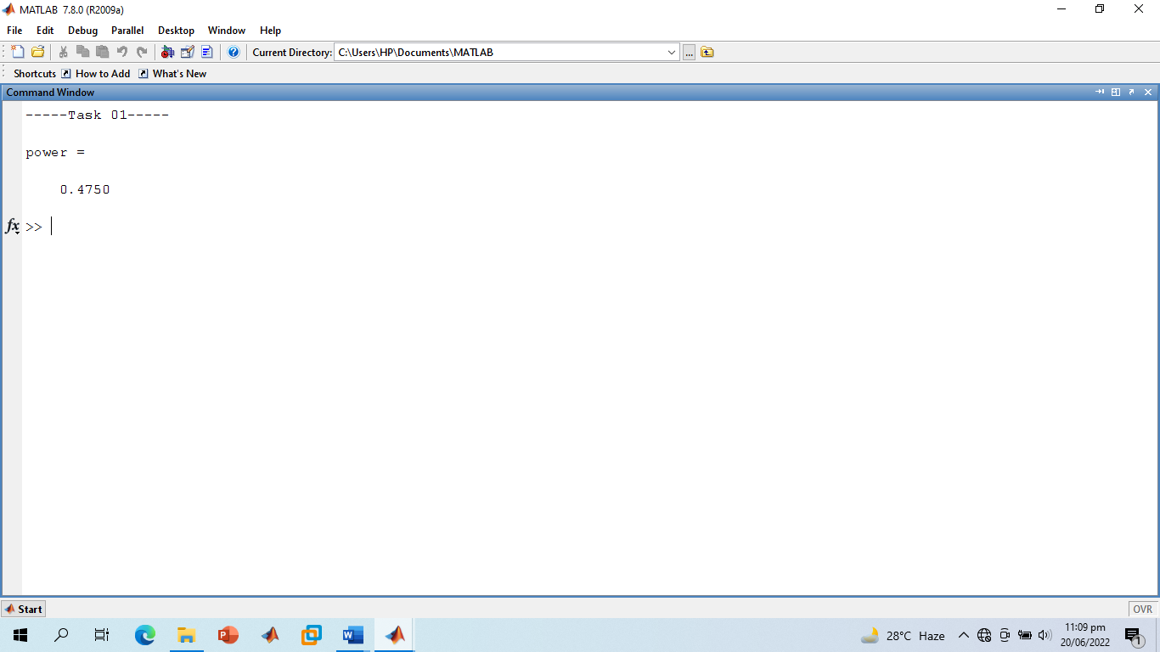

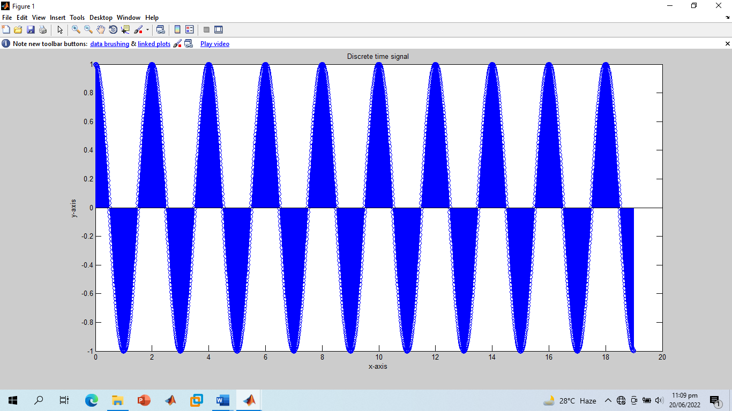

**-------------------------TASK 02--------------------------**

* Analyze the effect of Adding 1st to 17th harmonics and the effect of Adding 1st to 27th harmonics in above example.

**Screenshot of Input:**

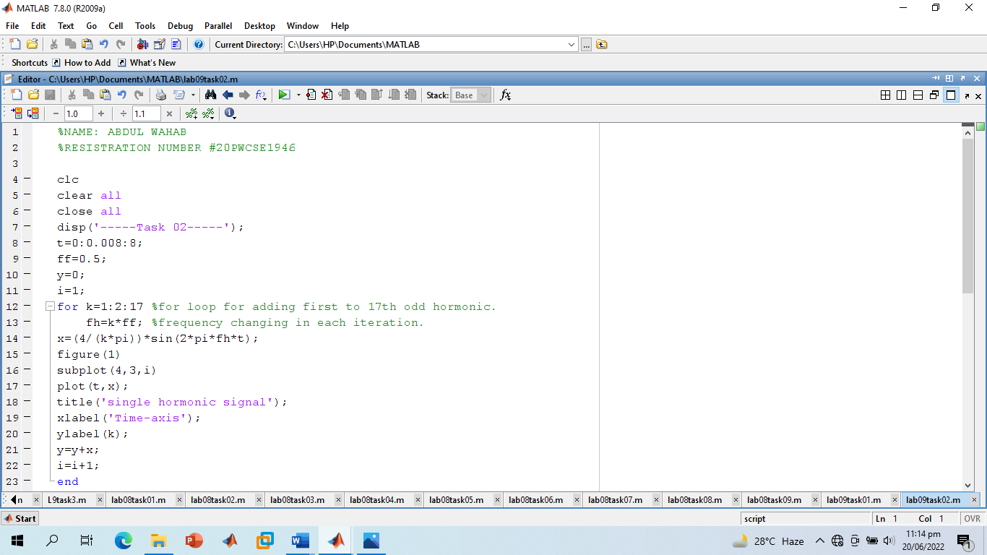

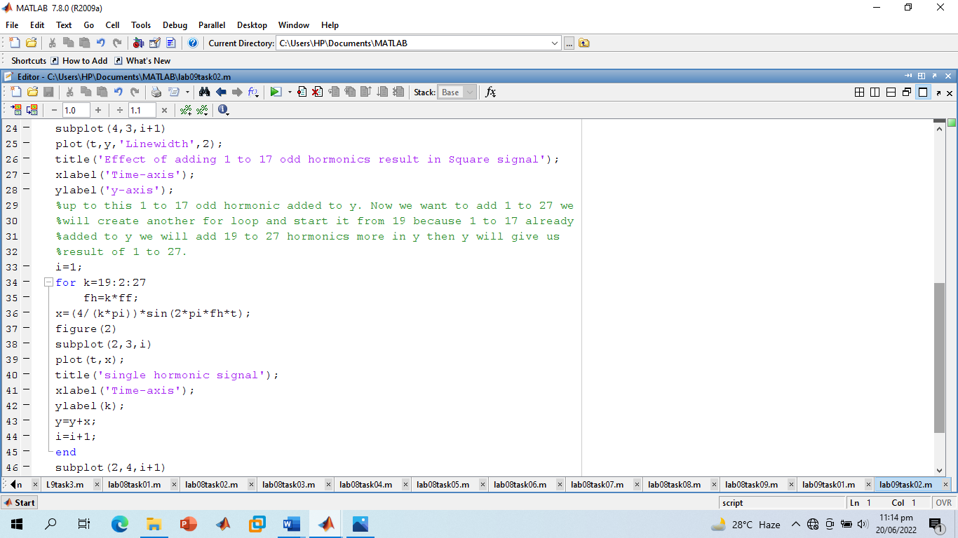

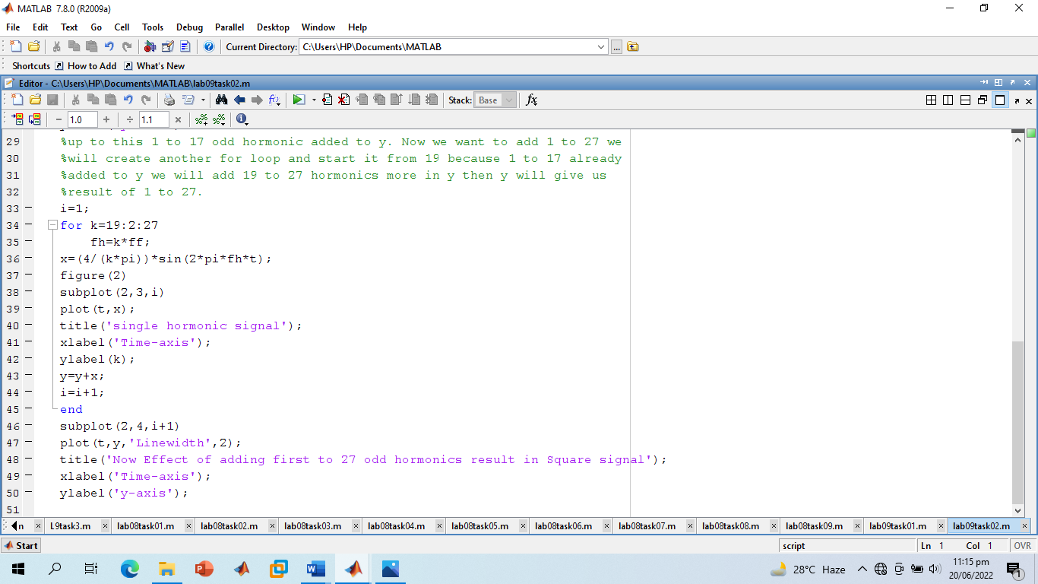

**Screenshot of Output:**

* **1 to 17th Odd harmonics and sum result of 1 to 17th harmonics.**

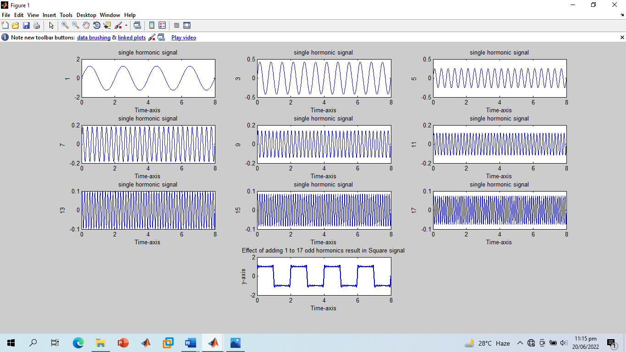

* **19th to 27th Odd harmonics and sum result of 1 to 27th harmonics.**

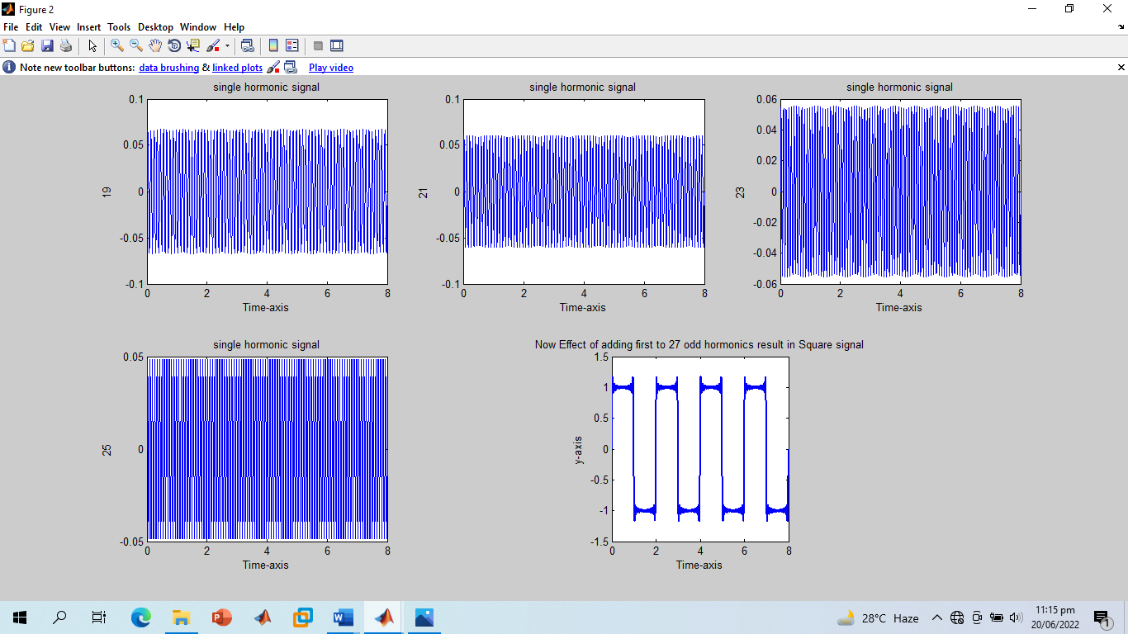

**-------------------------TASK 03--------------------------**

* Write a program that plots the signal s(t).



**OR**



* What do you conclude from TASKS 2 & 3?

**Screenshot of Input:**

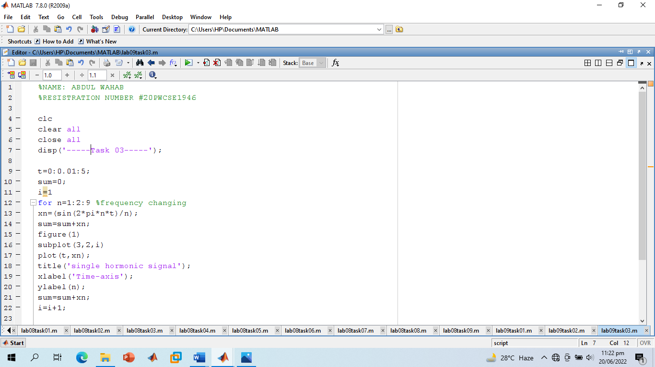

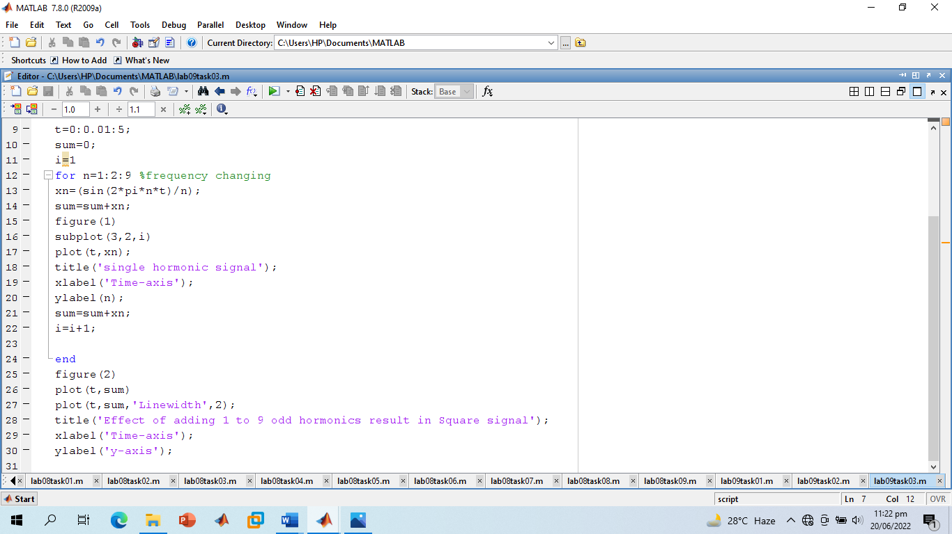

**Screenshot of Output:**

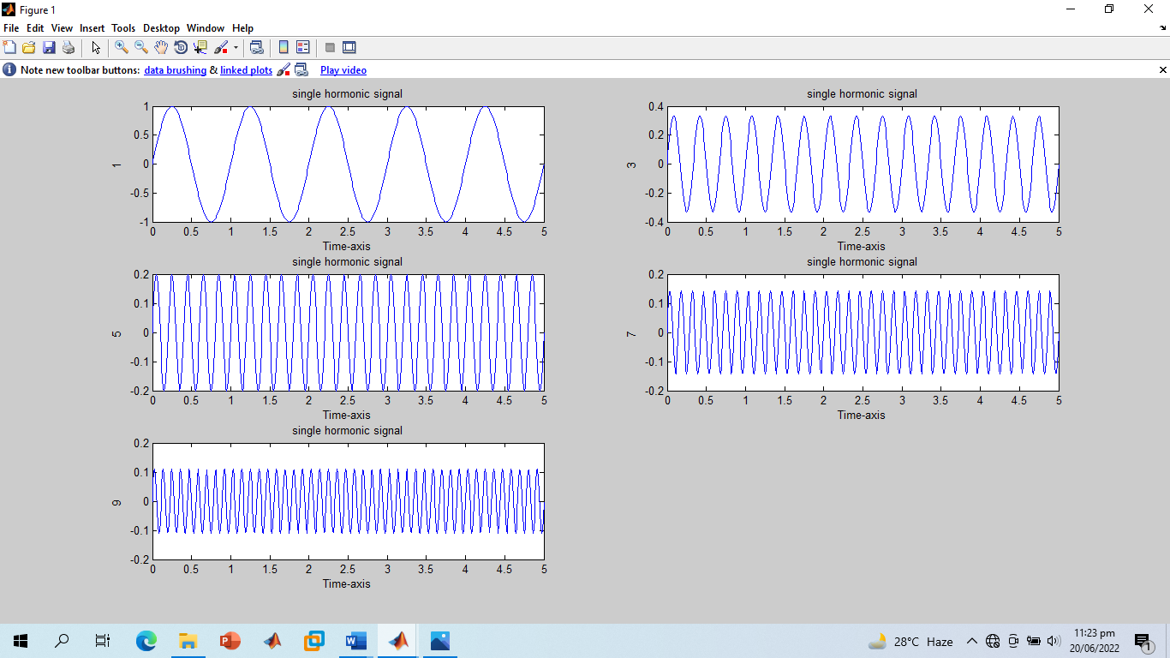

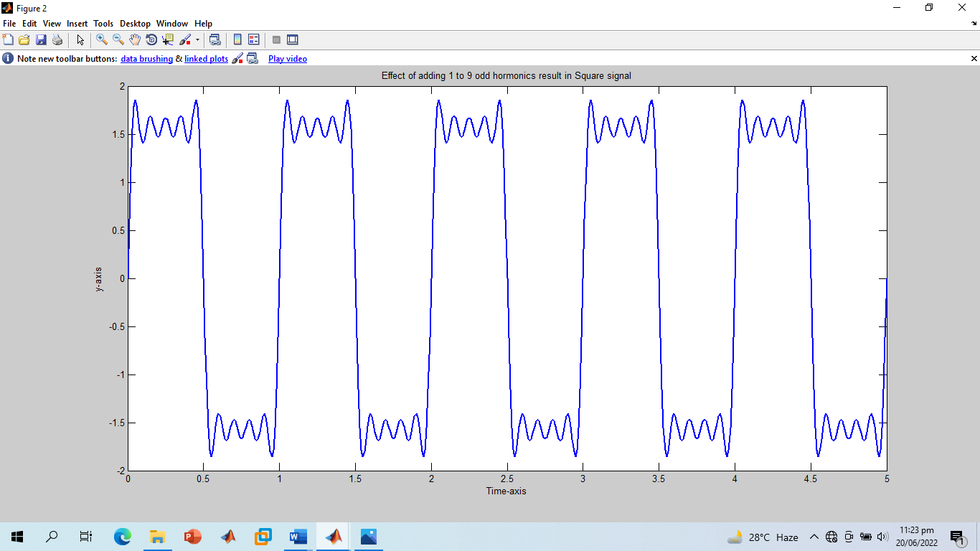

* The Output of Task 02 and 03 is almost same.

**-------------------------TASK 04--------------------------**

* Generate a **triangular wave with N=11.**

**Screenshot of Input:**

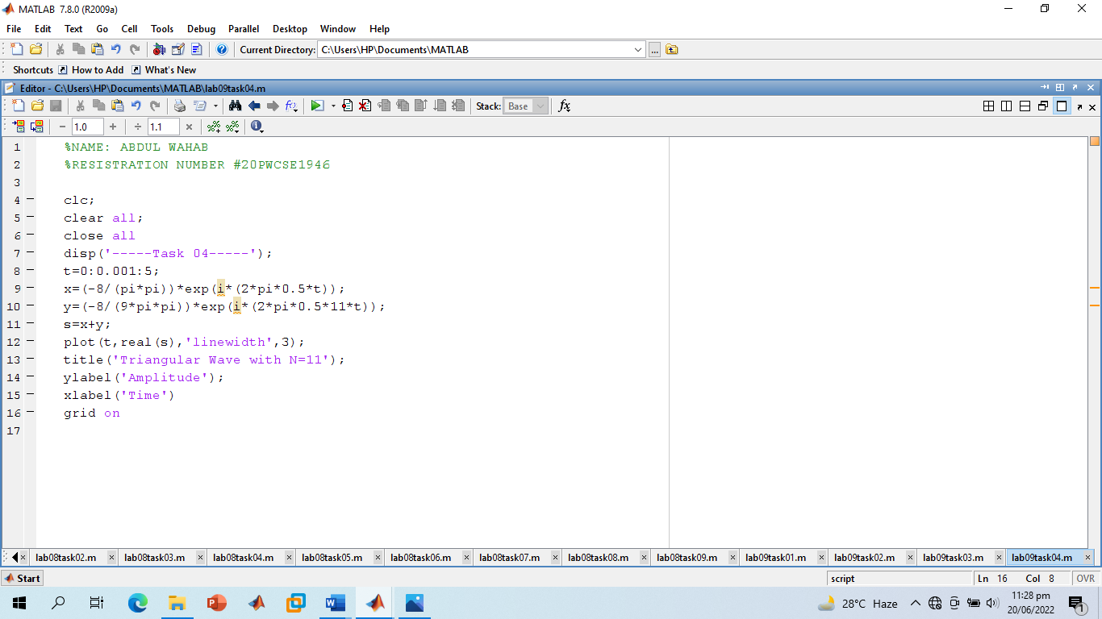

**Screenshot of Output:**

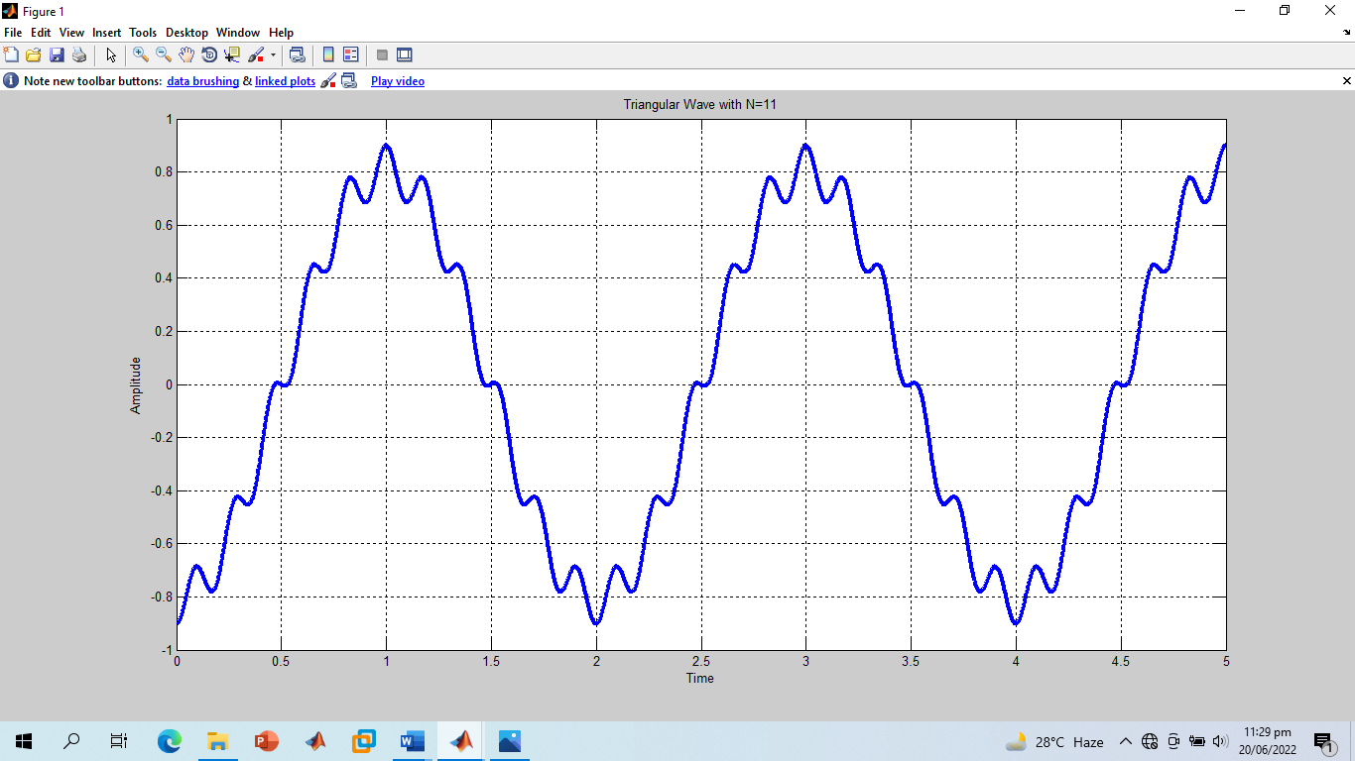

**------------------------------THE END------------------------------**